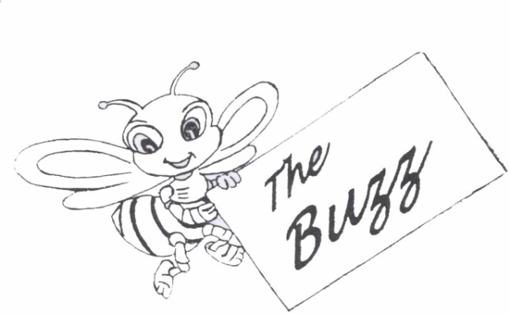

NEWS LETTER 40th Issue : Jan 2020

**The Colombo Academy of Language Skills and Dramatic Art**

77A, Fife Road ,Colombo 5. 🕿 011-2055087

011-2055088

Editor : Ishitha Mannapperuma

Dear Teachers,

A wonderful New Year has begun and it is time for a fresh start full of inspiration, optimism and positive thoughts. We take this opportunity to wish you all a Very Happy New Year! We hope you will embrace all your endeavours this year with a new outlook and have a productive year of teaching.

The CALSDA office is *buzzing* with excitement with preparations underway for a Teacher Training Programme. In this issue of *The Buzz* we would like to focus your attention on the details of Examinations for the year 2020.

**SYLLABUS FOR 2020**

The CALSDA syllabus for the year 2019 will remain valid for Examinations in the year 2020. Please do not hesitate to contact the CALSDA office should you need any assistance or clarification with regard to the syllabus. We shall be glad to assist you.

**INFORMATION BOOKLET**

Please use the General Information Booklet for Examinations in 2020 as a guideline for the new fee structure and added information on Examinations. If you have not received your copy, please make sure that you obtain one from the CALSDA office, or it can be posted on request.

**CALSDA WORKSHOP FOR TEACHERS**

The Colombo Academy of Language Skills and Dramatic Art will be conducting a Teachers Training Programme on **Sunday the 16th February 2020** at the **Sasakawa Memorial Hall**, No.4, 22nd Lane, Colombo 3.

The Board of Management of CALSDA invites all teachers to participate in this programme which is aimed at providing more information and clarifying any doubts on various aspects of teaching. You will receive a detailed notice in this regard along with this newsletter.

**EXAMINATIONS 2020**

**PRACTICAL EXAMINATIONS**

**First Session**

Period of Examinations - January - August 2020

Official closing date of entries - Friday 21st February 2020

**Second Session**

Period of Examinations - September -December 2020

Official closing date of entries - Friday 7th August 2020

**THEORY EXAMINATIONS**

**First Session**

Date of Examination - Saturday 30th May 2020

Official closing date of entries - Friday 21st February 2020

**Second Session**

Date of Examination - Saturday 24th October 2020

Official closing date of entries - Friday 7th August 2020

**PLEASE NOTE THAT THE CLOSING DATES FOR THE THEORY EXAMINATIONS WILL BE STRICTLY ADHERED TO. ENTRY FORMS AND BANK SLIPS SHOULD REACH THE CALSDA OFFICE NOT LATER THAN ONE WEEK AFTER THE OFFICIAL CLOSING DATE OF ENTRIES.**

**LATE ENTRIES FOR WRITTEN EXAMINATIONS WILL NOT BE ACCEPTED UNDER ANY CIRCUMSTANCES FROM 2020. WE KINDLY SUGGEST THAT YOU DO NOT MAKE ANY REQUESTS (EVEN FOR ONE SINGLE CANDIDATE TO BE ADDED TO YOUR ENTRIES.**

**THIS DECISION WAS MADE DUE TO MANY DIFFICULTIES FACED IN THE ALLOCATION OF ROOMS, THE OBTAINING OF CENTRES AND DISRUPTION CAUSED IN THE SCHEDULING OF CANDIDATES FOR EXAMINATIONS.**

**WE THANK YOU FOR YOUR CO-OPERATION.**

**KINDLY ALSO NOTE THAT WE WILL NOT BE ACCPETING ANY EXAMINATION ENTRY FEE PAYMENTS IN CASH AT THE CASLDA OFFICE.**

**ALL EXAMINATION ENTRY FEE PAYMENTS MUST BE DEPOSITED TO OUR BANK ACCOUNT NO. 1220000192 AT COMMERCIAL BANK NARAHENPITA OR ANY OTHER BRANCH OF THE COMMERCIAL BANK.**

***INSPIRE TO PROTECT***

***MOTHER EARTH***



We hold a responsibility to educate our young generation on the importance of preserving our natural resources for the continuation of life on Earth.

As catastrophic bushfires continue to rage a developed nation like Australia for months, it is evident that the effects of climate change are very real and affecting Mother Earth immensely.

Here are some poems that you can use to raise awareness on Climate Change and inspire your students to make the right choices that will make this world a better one for all of us to live in.

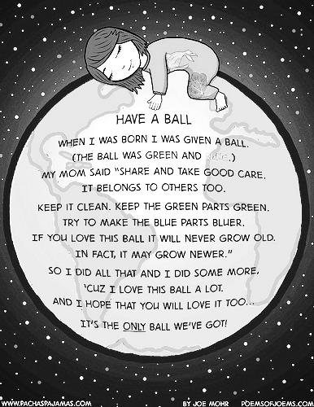

# Make It Green

# by Avani Desai

Lives are crying because it's not clean.  
Earth is dying because it's not green...  
  
Earth is our dear Mother; don't pollute it.  
She gives us food and shelter; just salute it...  
  
With Global Warming, it's in danger.  
Let's save it by becoming a strong ranger...  
  
With dying trees and animals, it's in sorrow.  
Make green today and green tomorrow...  
  
With melting snow, one day it will sink.  
How can we save it? Just think...  
  
Trees are precious, preserve them.  
Water is a treasure, reserve it...  
  
Grow more trees; make Mother Earth green.  
Reduce pollution and make her a Queen...

# Warned

by Sylvia Stults

The sands of time have rendered fear,  
Blue skies on high no longer clear.  
Stars were bright whence they came,  
Now dimmed, obscured, pollution's haze.  
  
Crystal clear our waters gleamed  
Fish abundant, rivers streamed.  
Ocean floors sandy white  
Now littered, brown, pollution's plight  
  
Trees towered high above,  
Trunks baring professed love.  
Birds chirping from sites unseen  
Gone, paper joined pollution's team.  
  
One can't blame pollution alone  
As they say, you reap what you've sown.  
So let us plant a better seed  
Tear out old roots, cultivate, weed.  
  
Protect what has been given for free  
Our waters, skies, wildlife and trees.  
For once they're gone, don't you say  
Consider yourself warned of that fatal day.

**WRITER’S PROFILE**

**Duncan Ball**

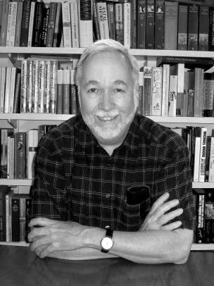

Duncan Ball is an American-born Australian multi-award winning author of over seventy-five books, as well as plays and television scripts.

Born in 1941 in Boston, Massachusetts, United States, Ball was one of three children. He finished his high school in the United States, studied at Northeastern University and, later, at the University of Paris (Sorbonne).

He moved to Sydney in 1974, where he worked as an industrial chemist with a passion for writing. He continued to work for a few years before resigning to become a full-time author.

‘**Selby’s Secret’** written in 1985 is one of his most popular books. It is a story about a dog named [Selby](https://en.m.wikipedia.org/wiki/Selby_the_Talking_Dog), who learned to talk while watching TV and struggles to keep his ability a secret (he must do this so his owners, the Trifles, do not put him to work around the house). Since this first book, 14 more original [Selby Books](https://en.m.wikipedia.org/wiki/Selby_Books) have been published, as well as a ‘**Selby's Selection’**book, featuring Selby's best antics.

In 1997, Duncan wrote the first ‘**Emily Eyefinger’** book, which is story about a girl named Emily who has an eye on the end of her finger. Ten books have been published in this series and it has been well-accepted by young readers. He has also written the Piggott books, which is about Bert Piggott and his useless family.

Duncan has also written single non-series books, such as **‘My Dog's a Scaredy Cat’**(1988) and **‘Jeremy's Tail’** (1990). One of his more recent popular books include a book of funny poems called **‘My Sister Has a Big Black Beard’**(2009).

Duncan Ball's books have won many **Children's Book Council of Australia Awards**, the **KOALA** (Kids Own Australian Literature Award---NSW) in 1997, 1998, 2000, 2001 and the **WAYRBA** (West Australian Young Readers’ Book Award), in 1987, 1989, 1990, 1991, 1997, 2001, 2003 and 2006.

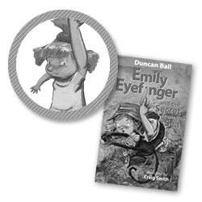

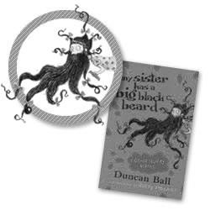

**INSPIRATION FOR THE NEW YEAR**

***Remember Your Passion for Teaching..***

Sometimes the idea of a fresh start (like the New Year) can help you remember your passion for teaching. It is easy to lose track of what initially motivated you to teach, especially when you have been at it for a long time. This new year, take some time to write down some of the reasons why you became a teacher in the first place. Remembering your drive and passion for teaching will help you keep going.

***Improve Your Time Management Skills..***

This new year, make an effort to improve your time management skills. Learn to prioritize your tasks and take advantage of technology to maximize your students’ learning time. Manage your day so that you have enough time to spend with your family doing things that you love too.

***Make your Classes Interesting..***

Every now and then, it is fun to spice things up. Find a few ways to change up your normal way that you do things and you will see the spark being lit in your classroom once again.



**EVERYONE NEEDS A LAUGH !**

Why did the teacher wear sunglasses in class?

Because the class was so bright.

What's a Teacher's Favorite Nation?

Expla-nation.

Which room can a teacher never enter?  
A Mushroom.

Father: How do you like going to school?

Son: The going bit is fine, as is the coming home bit too, but I'm not too keen on the time in-between!

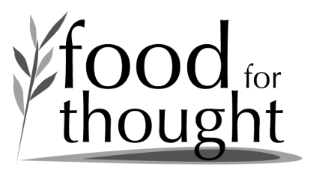

*“Students who are loved at home, come to school to learn and students who aren’t, come to school to be loved.” – Nicholas A. Ferroni*

*“Children are the living messages we send to a time we will not see.” – Neil Postman*

**Visit us on the World Wide Web**

Visit the CALSDA website at [www.calsda.org](http://www.calsda.org) for information on our examinations, syllabi, closing dates for entries and much more.

**TEACHER SUPPORT MATERIAL**

A series of work books, past question papers, specimen Spoken English passages for reading, re-telling and listening comprehension are available for sale at the CALSDA office. For rates of the books available, please check with the office staff. These materials can be purchased between 9.00 a.m. and 4.00 p.m. Monday to Friday.

………………………… ………………………….

Varuni Jayasekara Zulfika Musafer

Executive Director Director of Examinations

***For and on behalf of the Board of Management***