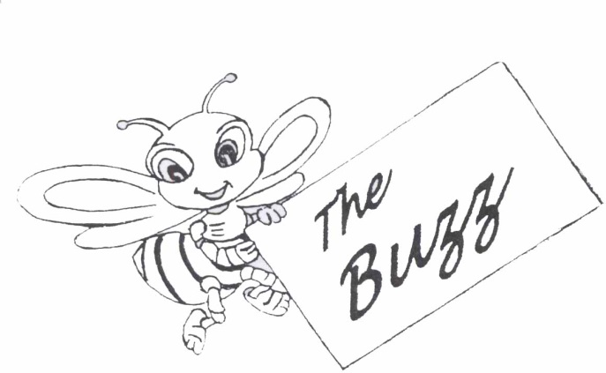

NEWS LETTER 35th Issue : July 2017

**The Colombo Academy of Language Skills and Dramatic Art**

77A, Fife Road ,Colombo 5. 🕿 011-2055087

011-2055088

Editor : Ishitha Mannapperuma

Dear Teachers,

We hope that all of you have had a productive year of teaching so far. The CALSDA office is *buzzing* with excitement this time around with preparations for the second session of Examinations for the year 2017.

In this issue of *The Buzz* we would like to focus your attention on the details relating to the second session of Examinations.

**SECOND SESSION OF EXAMINATIONS 2017**

**PRACTICAL EXAMINATIONS**

**Second Session**

Period of Examinations - September -December 2017

Official closing date of entries - Friday 4th August 2017

**THEORY EXAMINATIONS**

**Second Session**

Date of Examination - Saturday 21st October 2017

Official closing date of entries - Friday 4th August 2017

**PLEASE NOTE THAT THE CLOSING DATES FOR THE THEORY EXAMINATIONS WILL BE STRICTLY ADHERED TO. LATE ENTRIES WILL BE ACCEPTED (AFTER THE OFFICIAL CLOSING DATE) ONLY UP TO ONE WEEK AFTER THE CLOSING DATE. ENTRY FORMS AND BANK SLIPS SHOULD REACH THE CALSDA OFFICE NOT LATER THAN ONE WEEK AFTER THE OFFICIAL CLOSING DATE OF ENTRIES.**

**KINDLY ALSO NOTE THAT WE WILL NOT BE ACCPETING ANY EXAMINATION ENTRY FEE PAYMENTS IN CASH AT THE CASLDA OFFICE.**

**ALL EXAMINATION ENTRY FEE PAYMENTS MUST BE DEPOSITED TO OUR BANK ACCOUNT NO. 1220000192 AT COMMERCIAL BANK NARAHENPITA OR ANY OTHER BRANCH OF THE COMMERCIAL BANK.**

***LET’S PREVENT THE SPREAD OF DENGUE***

[](https://images.search.yahoo.com/images/view;_ylt=AwrB8pd9K3dZBlwACVCJzbkF;_ylu=X3oDMTIyYnZnMTNuBHNlYwNzcgRzbGsDaW1nBG9pZANmYTdjMzU3MzYyMjdhNDhlOTMwOTZiYWY0ZGNiZDg5MwRncG9zAzEEaXQDYmluZw--?.origin=&back=https://images.search.yahoo.com/search/images?p=mosquito+prevention+sign&fr=yfp-t&fr2=piv-web&tab=organic&ri=1&w=612&h=792&imgurl=4.bp.blogspot.com/-B7CTY9B0KH8/UZESrG21LgI/AAAAAAAACS0/_XvRe06_RQk/s1600/Fight+the+Bite+Sign1.jpg&rurl=http://thelacombecityhallblog.blogspot.com/2013/05/fight-bite-mosquito-prevention-in.html&size=28.0KB&name=Fight+The+Bite!+%3cb%3eMosquito%3c/b%3e+%3cb%3ePrevention%3c/b%3e+in+Lacombe&p=mosquito+prevention+sign&oid=fa7c35736227a48e93096baf4dcbd893&fr2=piv-web&fr=yfp-t&tt=Fight+The+Bite!+%3cb%3eMosquito%3c/b%3e+%3cb%3ePrevention%3c/b%3e+in+Lacombe&b=0&ni=21&no=1&ts=&tab=organic&sigr=12pk5u4ah&sigb=13eso6q6e&sigi=131dsvid0&sigt=11s3r6rbs&sign=11s3r6rbs&.crumb=ooOjdDzuhNO&fr=yfp-t&fr2=piv-web)

The dengue epidemic has presently become a serious health issue in various parts of Sri Lanka.

As teachers, we have a responsibility to ensure that students in our classrooms are protected against dengue mosquitoes.

Here are a few simple and practical steps that can be practiced in order to safeguard our classrooms against mosquitoes :

1. Keep the classroom and its vicinity clean in order to reduce mosquito habitats. (For example remove and properly discard all unnecessary water collecting containers in your vicinity while keep your roof gutters clean to ensure there is no stagnation of water.)

2. Instruct parents to apply mosquito repellent lotions or oils on all exposed areas of their child’s body when attending classes.

3. Encourage students to wear protective clothing such as long sleeve shirts/blouses, long pants/skirts and socks for classes to guard their skin from mosquito bites.

4. Use mosquito repellent remedies such as mosquito coils or citronella oil sprays in your classrooms.

Let’s do whatever we can to protect our children from the deadly Dengue mosquitoes!



**Visit CALSDA on the World Wide Web**

Visit the CALSDA website at [**www.calsda.org**](http://www.calsda.org) for information on our examinations, syllabi, closing dates for entries and much more.

**The Making of a 21st Century Educator:**

**5 Ways to be a Better Teacher in Today’s Classroom**

1. **Be forward thinking.**

The 21st century educator must have a broader vision, anticipating and adapting to trends, not only in education, but technology and science as well. Teachers are tasked with preparing students, not for the world as it exists today, but for the one they will someday inherit.

1. **Be an eager learner.**

Technology has become a fundamental part of our students' daily experience, both in and out of the classroom. Educators operating in such a rapidly evolving technological climate simply must be willing to learn to effectively teach. The phrase "lead by example" comes to mind. If we want our students to be inquisitive, open-minded and willing to learn from making mistakes, so must be our teachers.

1. **Be a builder of relationships.**

Today's students are more likely to gauge their number of friends on Facebook than by who sits with them in the classroom. In such a world of technological isolation, where it is possible to go through an entire day without real human interaction, we must facilitate interpersonal relationships within the classroom while prioritizing communication, respect and cooperation.

1. **Be equipped to teach all levels of learners.**

As effective 21st century educators, we not only need to be armed with the same characteristics and skills we plan to impart on our students, we must also have the ability to teach those characteristics and skills to every student at every level in the classroom. This includes the ability to effectively relate to students and teach to their unique learning styles.

1. **Be able to implement technology effectively.**

Enhancing the educational environment with technology can facilitate faster learning and streamline teacher tasks, such as grading, planning and presenting lessons, but simply putting a computer in front of your students isn't enough. Technology can just as easily be distracting or unproductive. An effective 21st century educator will have the discernment and know-how to incorporate technology into the classroom in a way that facilitates, rather than distracts from, teaching and learning.

 (An article extracted from the Internet.)

**A WAY WITH WORDS**

**Zigzags** are an interesting new word puzzle with very simple directions.

First complete the 7-letter word at the top of the diagram. Them use the last two letters of the first word as the first two letters of the second word. Continue the same to guess the words below.

PUZZLE 1 PUZZLE 2

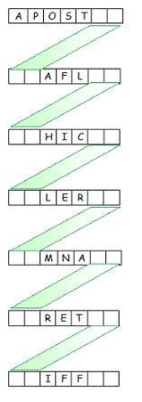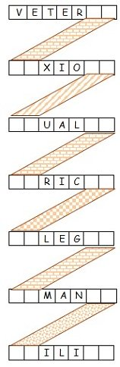

**EVERYONE NEEDS A LAUGH**

Teacher: Tell me a sentence that starts with an "I".   
Student: I is the....  
Teacher: Stop! Never put 'is' after an "I". Always put 'am' after an "I".  
Student: OK. I am the ninth letter of the alphabet.

………………………………………………………………….Two boys were arguing when the teacher entered the room.

The teacher asked, "Why are you arguing?"

One boy answered, "We found a ten dollar bill and decided to give it to whoever who tells the biggest lie."

"You should be ashamed of yourselves," said the teacher, "When I was your age I didn't even know what a lie was."

The boys immediately gave the ten dollars to the teacher.

**WRITER’S PROFILE**

,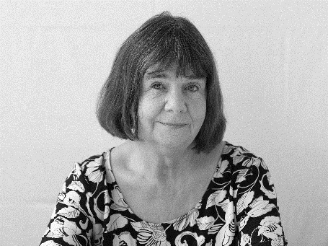

**Julia Donaldson**

**Julia Donaldson** [**MBE**](https://en.wikipedia.org/wiki/MBE) is an acclaimed contemporary English writer, poet, playwright and performer.

She is best known for her popular rhyming stories for children, especially those illustrated by [Axel Scheffler](https://en.wikipedia.org/wiki/Axel_Scheffler), which include ‘[***The Gruffalo****’*(1999)](https://en.wikipedia.org/wiki/The_Gruffalo), ‘[***Room on the Broom***](https://en.wikipedia.org/wiki/Room_on_the_Broom)’(2001), ‘[***The Gruffalo’s Child****’*(2004)](https://en.wikipedia.org/wiki/The_Gruffalo) and ‘[***Stick Man***](https://en.wikipedia.org/wiki/Stick_Man)*’* (2008*)*.

Born in 1948, Donaldson was brought up in [Hampstead](https://en.wikipedia.org/wiki/Hampstead), London with her younger sister, parents and extended family all sharing the family home. Her first interests were firmly rooted in music, her father being a Cello player and her mother a keen singer; herself and her sister were also members of the Children’s Opera Group.

Donaldson went on to study Drama and French at [Bristol University](https://en.wikipedia.org/wiki/Bristol_University) from 1967 to1970.

She originally wrote songs for children's television but has concentrated on writing books since the words of one of her songs, "A Squash and a Squeeze", were made into a children's book in 1993.

He second book published in 1999, ‘***The Gruffalo****’*, has sold over 3.5 million copies and remains a firm favourite of children, both big and small. It has also been released as an audio book, soft toy and musical CD. ‘***The Gruffalo****’* has also been performed as a musical stage play both in London and on Broadway, New York. A multi award winning book, the sequel ‘The Gruffalo’s Child’ released in 2004 has also received recognition and accolade.

Donaldson was awarded the MBE (Member of the Order of the British Empire) in the 2011 Queen's Birthday Honour List for her services to Literature.

[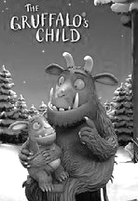](http://www.imdb.com/title/tt2132486/?ref_=nm_knf_i3)

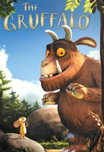

The Gruffalo (1999) The Gruffalo’s Child (2004)

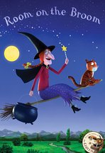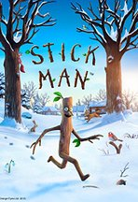

Room on the Broom (2001) Stick Man (2008)

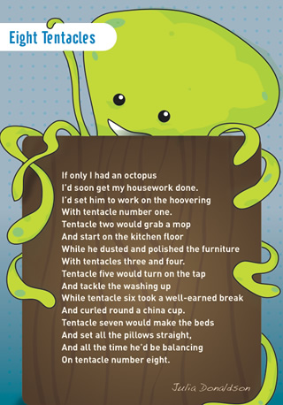

*[](https://www.bing.com/images/search?q=borders+clipart+hd&view=detailv2&&id=501D835DB7B33EAF06DDC8881C26A552A1E2792B&selectedIndex=24&ccid=8jwo46b4&simid=608008482225719613&thid=OIP.Mf23c28e3a6f878414a37c04baa41c0e9H0)*

## *Heart of A Teacher* **by Paula J. Fox**

The child arrives like a mystery box…  
with puzzle pieces inside  
some of the pieces are broken or missing…  
and others just seem to hide

But the HEART of a teacher can sort them out…  
and help the child to see  
the potential for greatness he has within…  
a picture of what he can be

Her goal isn’t just to teach knowledge…  
by filling the box with more parts  
it’s putting the pieces together…  
to create a work of art.

The process is painfully slow at times…  
some need more help than others  
each child is a work in progress…  
with assorted shapes and colors

First she creates a classroom…  
where the child can feel safe in school  
where he never feels threatened or afraid to try…  
and kindness is always the rule

She knows that a child can achieve  
much more when he feels secure inside  
when he’s valued and loved…and believes in himself …  
and he has a sense of pride

She models and teaches good character…  
and respect for one another  
how to focus on strengths…not weaknesses  
and how to encourage each other

She gives the child the freedom he needs…  
to make choices on his own  
so he learns to become more responsible…  
and is able to stand alone

He’s taught to be strong and think for himself…  
as his soul and spirit heal  
and the puzzle that’s taking shape inside…  
has a much more positive feel

The child discovers the joy that comes…  
from learning something new…  
and his vision grows as he begins  
to see all the things he can do

A picture is formed as more pieces fit…  
an image of the child within  
with greater strength and confidence…  
and a belief that he can win!

All because a hero was there…  
in the HEART of a teacher who cared  
enabling the child to become much more…  
than he ever imagined…or dared

A teacher with a HEART for her children…  
knows what teaching is all about  
she may not have all the answers…  
but on this…she has no doubt

When asked which subjects she loved to teach,  
she answered this way and smiled…  
“It’s not the subjects that matter…

**It’s all about teaching the CHILD.**”

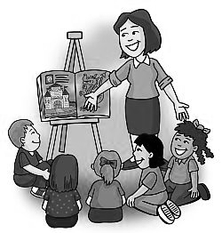

**TEACHER SUPPORT MATERIAL**

A series of work books, past question papers, a CD of vocabulary pronunciation (Grades Introductory to Six), specimen Spoken English passages for reading, re-telling and listening comprehension are available for sale at the CALSDA office. For revised rates of the books available, please check with the office staff. These material can be purchased between 9.00 a.m. and 4.00 p.m. Monday to Friday.

………………………… ………………………….

Varuni Jayasekara Zulfika Musafer

Executive Director Director of Examinations

***For and on behalf of the Board of Management***



NEWS LETTER 34th Issue : Jan 2017

**The Colombo Academy of Language Skills and Dramatic Art**

18/15, Chitra Lane, Off Kirula Road, Colombo 5 🕿 011-2555832

011-2599935

Editor : Ishitha Mannapperuma

Dear Teachers,

Every New Year gives you the perfect chance to start afresh. We hope you will embrace all your endeavours in 2017 with a new outlook and have a wonderful year of educating the future generation of our country. We at CALDA take this opportunity to wish you all a Very Happy New Year!

This time around the CALSDA office is *buzzing* with excitement with preparations underway for a Workshop.

In this issue of *The Buzz* we would like to focus your attention on the details of these special events and other details of Examinations for the year 2017.

**PRACTICAL EXAMINATIONS 2017**

**First Session**

Period of Examinations - January - August 2017

Official closing date of entries - Friday 24th February 2017

**Second Session**

Period of Examinations - September -December 2017

Official closing date of entries - Friday 4th August 2017

**THEORY EXAMINATIONS 2017**

**First Session**

Date of Examination - Saturday 27th May 2017

Official closing date of entries - Friday 24th February 2017

**Second Session**

Date of Examination - Saturday 21st October 2017

Official closing date of entries - Friday 4th August 2017

**PLEASE NOTE THAT THE CLOSING DATES FOR THE THEORY EXAMINATIONS WILL BE STRICTLY ADHERED TO. LATE ENTRIES WILL BE ACCEPTED (AFTER THE OFFICIAL CLOSING DATE) ONLY UP TO ONE WEEK AFTER THE CLOSING DATE. ENTRY FORMS AND BANK SLIPS SHOULD REACH THE CALSDA OFFICE NOT LATER THAN ONE WEEK AFTER THE OFFICIAL CLOSING DATE OF ENTRIES.**

**SYLLABUS FOR 2017**

The new CALSDA syllabus for the year 2017 is ready for purchase at our office. Please do not hesitate to contact the CALSDA office should you need any assistance or clarification with regard to the syllabus. We shall be glad to assist you.

**ANNUAL PRIZE GIVINGS 2017**

The annual Prize Givings for candidates who obtained the highest marks in their grades in examinations conducted in 2016, will be held in two sessions in March and April 2017. More information on the Prize Giving functions will be notified in the due course.

***CALSDA WORKSHOP***

***FOR TEACHERS***

The Colombo Academy of Language Skills and Dramatic Art will be conducting a teachers training workshop on **Sunday the 29th January 2017** from **8.30 a.m. to 3.00 p.m.** at the **Sasakawa Memorial Hall**, No.4, 22nd Lane, Colombo 3.

The Board of Management of CALSDA invites all teachers to participate in this programme which is aimed at providing more information and clarifying any doubts on various aspects of teaching.

There will be interactive demonstrations and presentations made on various aspects of the syllabus by the members of the Panel of Examiners. You will receive a detailed notice in this regard along with this newsletter.

**COLLECTION OF WRITTEN ENGLISH EXAMINATION RESULTS**

This is a gentle reminder to teachers who have not collected the results of their students who sat for the the second session of Written Examinations held in October 2016. Kindly collect your students’ Result Sheets and Certificates from the CALSDA office between 9.00 a.m. and 4.00 p.m. Monday to Friday at your earliest.



**EVERYONE NEEDS A LAUGH**

The parents were very disappointed in the grades that their son brought home. “The only consolation that I can find in these awful grades,” lamented the father, “is that I know he never cheated during his exams.”

A teacher was having trouble teaching arithmetic to one little boy. So she said, “If you reached in your right pocket and found a nickel, and you reached in your left pocket and found another one, what would you have?”

“Somebody else’s pants.”

The teacher was droning away in the classroom when he noticed a student sleeping in the back row. The teacher shouts to the sleeping students neighbour, “Hey, wake that student up!” The neighbour says, “Sir, you put him to sleep, it’s best that you wake him up!”

A student was taking a true-false test and was flipping a coin to guess his answers. At the end of the test just before the answer sheets were collected, he was flipping the coin again. The teacher asked him, “Jimmy, what are you doing?” Jimmy replied, “Checking my answers.”

A teacher writes on a chalkboard the sentence:

“ A woman without her man is nothing”

The teacher the asks the boys to punctuate it properly, and they all write:”

“A woman, without her man, is nothing.”

The teacher asks the girls to punctuate it and they write:

“A woman, without her, man is nothing.”



**Inspiration For Teachers**

*‘Teaching is a very noble profession that shapes the character, caliber, and future of an individual. If the people remember me as a good teacher, that will be the biggest honour for me.’*  **- A. P. J. Abdul Kalam**

*‘I have come to believe that a great teacher is a great artist and that there are as few as there are any other great artists. Teaching might even be the greatest of the arts since the medium is the human mind and spirit.’*

- **John Steinbeck**

*‘A teacher affects eternity; he can never tell where his influence stops.’*  - **Henry Adams**

*‘I have learned that, although I am a good teacher, I am a much better student, and I was blessed to learn valuable lessons from my students on a daily basis. They taught me the importance of teaching to a student - and not to a test.’*  - **Erin Gruwell**

*‘A good teacher, like a good entertainer first must hold his audience's attention, then he can teach his lesson.’*

**- John Henrik Clarke**

‘*Every child deserves a champion – an adult who will never give up on them, who understands the power of connection and insist that they become the best that they can possibly be.’* **- Rita Pierson**

**TEACHER SUPPORT MATERIAL**

A series of work books, past question papers, a CD of vocabulary pronunciation (Grades Introductory to Six), specimen Spoken English passages for reading, re-telling and listening comprehension are available for sale at the CALSDA office. For revised rates of the books available, please check with the office staff. These material can be purchased between 9.00 a.m. and 4.00 p.m. Monday to Friday.

………………………… ………………………….

Varuni Jayasekara Zulfika Musafer

Executive Director Director of Examinations

***For and on behalf of the Board of Management***